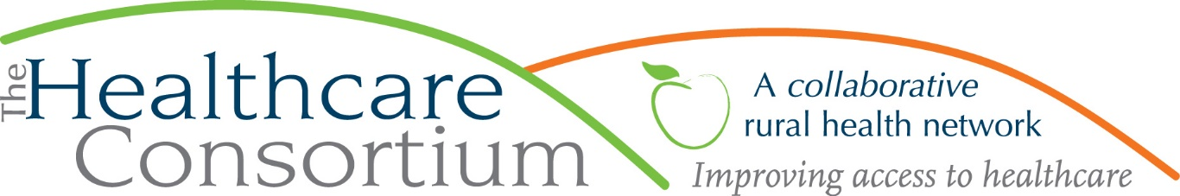

Smoking & Cannabis: What You Need to Know

By Karen dePeyster, Tobacco-Free Action

After years of eager anticipation by some and with mounting trepidation from others, New York State legalized the recreational use of marijuana in March of this year. Adults 21 and older are now allowed to possess up to three ounces of cannabis and to use, smoke, ingest or otherwise consume cannabis products. They can also give (but not sell) them to others who meet the same age requirement. A new state agency, the Office of Cannabis Management, is being created to oversee and implement the law and will eventually write rules to establish and regulate adult-use cannabis retail dispensaries and on-site consumption licenses and to clarify other aspects of the law. In the meantime, here are a few commonly asked questions:

Q: Can counties opt-out?

A: Cities, towns, and villages (but not counties) can opt-out of allowing adult-use cannabis retail dispensaries or on-site consumption licenses from locating within their jurisdictions. Municipalities cannot opt-out of adult-use legalization.

Q: Is smoking cannabis allowed anywhere?

A: No. New York’s Clean Indoor Air Act now applies to smoking both tobacco and cannabis (and to vaping.) The long list of places the CIAA prohibits smoking includes: all indoor worksites and places of employment; bars and restaurants; mass transportation, such as subways, buses, vans, taxis and limousines; public transportation terminals; schools, colleges and universities; childcare facilities; indoor arenas; zoos; grounds of hospitals, residential healthcare facilities and public libraries. The Marijuana Regulation & Taxation Act (MRTA) also prohibits smoking cannabis in cars and other vehicles. As a general rule, where smoking tobacco is allowed, so is smoking cannabis; where smoking tobacco is prohibited, so is smoking cannabis.

Q: Can localities impose their own rules on smoking cannabis?

A: Yes. Towns, villages, cities and counties can adopt rules to regulate smoking tobacco and cannabis in public places. For example, smoking is not allowed in most town and village parks in Columbia and Greene Counties. We are urging municipalities to upgrade these policies to include vaping (some forms of marijuana can be used in vaping devices) and to include language that specifically references cannabis; such as:

"Smoking" means inhaling, exhaling, burning, vaping or carrying any lighted or heated cigar, cigarette, pipe, or any other lighted or heated tobacco, nicotine, or plant product, including cannabis, intended for inhalation, in any manner or in any form.”

Q: Can owners of multi-unit housing properties prohibit tenants from smoking marijuana on the premises, including living-units and common areas?

A: Yes. Property owners have the legal authority it make apartment buildings and other multi-unit housing smoke-free, including both tobacco and marijuana smoke. Secondhand smoke from both sources spreads in dwellings through air ducts, under doors, through walls and open windows. Marijuana smoke contains many of the same toxic chemicals and fine inhalable particles as tobacco smoke. In addition to creating a healthier indoor environment, a smoke-free housing policy reduces upkeep and turnover costs, lowers the risk for fire, and is preferred by non-smokers who constitute the majority of residents.

Since cannabis is still illegal under federal law, Public Housing Authorities cannot include it in the smoke-free policy that has been mandated by HUD.

One of the principle missions of the Tobacco-Free Action program is help create smoke-free environments, both inside and in outdoor spaces. For officials who oversee town and village parks and for owners of multi-unit housing properties, we can be a resource to help you craft or upgrade a smoking policy that includes cannabis. For example, we provide sample policy language, free custom-made signage, and, for housing properties, step-by-step implementation guidance. We will also receive official announcements as parts of the Cannabis Law are clarified and can pass this information on to you.
To request assistance, please contact us at 518-822-0999, or by email to Sarah Trafton, strafton@columbiahealthnet.org; or Karen dePeyster, karen@columbiahealthnet.org.
***
The Healthcare Consortium is a local charitable organization with a mission of improving access to healthcare and supporting the health and well-being of the residents in our rural community. The agency is located at 325 Columbia St. in Hudson. For more information: visit www.columbiahealthnet.org or call 518-822-8820.

