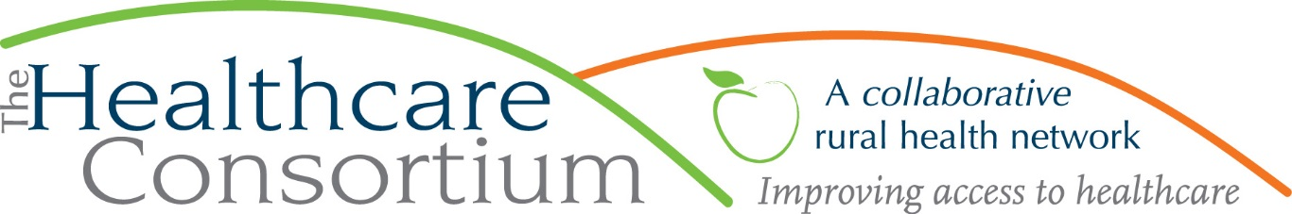

NYConnects: Never the Wrong Door
By: Lisa Thomas
Director of Consumer Assistance Programs

NYConnects, a program of the Healthcare Consortium that is supported by our partners at the Columbia County Office for the Aging, has been assisting the community for over 10 years and is delighted to continue providing information and assistance to individuals in need of long-term services and supports. Our NYConnects Program has new staff who are eager to help you through any challenges you may be facing and will work diligently to answer your questions and connect you with the assistance you may need. We look forward to getting back out in the community and seeing you at different site locations and outreach events as they arise.
You may be wondering what “long-term services and supports” are. Long-term services and supports, or LTSS, are both medical and non-medical services that help individuals address the functional deficits that would otherwise affect their ability to live safely and independently at home. LTSS can include things such as in-home healthcare, respite care, home-delivered meals, transportation, counseling, and housing. NYConnects provides helpful, unbiased information about the availability of and access to long-term services and supports for anyone with reduced function — whether those challenges are due to age, physical disability, intellectual or developmental disability, mental illness and/or substance use disorder — to support their independent living.
Our work at NYConnects begins with a conversation with individuals or their caregivers to discuss current needs, identify barriers, and ultimately make a connection to the services and supports in the community that will help maintain independence and enhance quality of life. We also assist people to negotiate the ins and outs of Medicare and the Medicare Savings Programs, Medicaid, the Home Energy Assistance Program (HEAP), and the Supplemental Nutrition Assistance Program (food stamps). Each of these programs and their applications can seem complicated and overwhelming the first time they are encountered. Happily, NYConnects Information and Assistance Specialists can help.
Moreover, NY Connects serves as the hub of an entire “No Wrong Door” Network of agencies, organizations and businesses who collaborate to help individuals with long-term care needs. Through our long and positive working relationships with a variety of partners, we are able to facilitate connections and marshal resources on behalf of our clients that takes the mystery, the headache and the legwork out of navigating a complex system.
As a reminder, funding is available to respond to the emergent and critical needs of seniors and individuals with disabilities resulting from the COVID-19 pandemic. Financial and other forms of assistance are available to help eligible residents to purchase and/or get delivery of meals and groceries, pay rent, address personal care needs, and get or maintain internet access. If you or a loved one are a senior or an individual with a disability who has struggled to meet basic needs as a result of the COVID-19 pandemic, there IS help to get through this difficult time.
At the Healthcare Consortium, we are NEVER the wrong door, so if you have an unanswered question - or don’t even know the “right” question to ask - never hesitate to contact us. We can help you to figure out the question, and then we will help you find the answer! Contact information for Columbia County NY Connects Program is (518) 828 - CARE (2273) or toll free at 1-877-260-9244. You can also access our online resource directory at https://nyconnects.ny.gov .
***
The Healthcare Consortium is a non-profit organization with a mission of improving access to healthcare and supporting the health and well-being of the residents in our rural community. The agency is located at 325 Columbia St. in Hudson. For more information: visit www.columbiahealthnet.org or call 518-822-8820.

