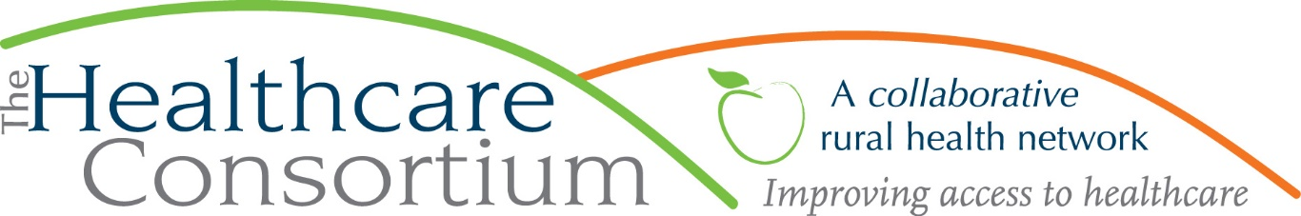

Advocating for Rural Health
By Claire Parde

The early part of every calendar year is “prime time” for the Healthcare Consortium’s state advocacy efforts. This is due, in part, to the annual state budget process, and the release of a comprehensive, balanced budget proposal from the Governor’s Office, along with the related appropriation, revenue and budget bills. From that moment forward, a mad scramble begins, to digest the Executive Budget, and consider its implications; for us, that means looking for the things that are important to the health and well-being of rural people and places. Thereafter, and with the help of our partners, we put together a list of priorities, some of which may already be reflected in the Executive Budget and others that may be absent from it. Here is our list of priorities this year (with more information to be found at www.columbiahealthnet.org):
- Enhancing the Investment in Rural Health Programs
- Empaneling the Rural Health Council
- Enhancing Support for Rural Emergency Medical Services (EMS)
- Continuing Drug Maker Discounts to Rural Hospitals and Community Health Centers
- Ensuring Adequate Public Health Infrastructure
- Supporting Mental and Behavioral Health Services
- Supporting Aging and Disability Services
- Expanding Rural Broadband and Telehealth
- Promoting Workforce Recruitment, Training, and Retention

Some of these priorities are particular to rural areas, like advocating for an enhanced investment in the State’s Rural Health Programs that provide funding to rural hospitals (like CMH) and rural health networks (like the Healthcare Consortium and the Greene County Rural Health Network). Other priorities, like growing the healthcare workforce, may be relevant for all parts of the State, but are so important to our rural community that we add our “rural voice” to the chorus of advocates asking for investments in this area.

With a list of priorities in hand, we then start the work of advocating with our state elected officials and their staff. Visits with legislators are surprisingly informal and comfortable things. Our elected officials depend on an active citizenry to both signal what things they should be thinking and caring about and also to educate them about the issues. A legislator’s knowledge is often a mile wide and an inch deep; while they have been exposed to a wide, wide array of issues, their understanding of those issues is naturally less than that of someone who is wholly focused on them. Therefore, legislators and their staff are often grateful for the opportunity to meet with and learn from their constituents.
While advocates are frantically meeting with legislators in response to the Executive Budget, another critically important step in the annual budget process is underway. The Legislature, primarily through its two fiscal committees –the Senate’s Finance Committee and the Assembly’s Ways and Means Committee– analyzes the Governor’s spending proposals and revenue estimates, holds public hearings on major programs, and seeks further information from the Division of the Budget and other State agencies. This provides another opportunity for rural health advocates, who can provide testimony for the public hearings. In the early part of February, we will be part of an effort to provide written testimony about all the rural health priorities noted above to reinforce and amplify what has already been said in our legislative visits.

By mid-March, the Assembly and Senate will release their “one-house” budget proposals, which must get reconciled to reach agreement on a budget by the April 1st deadline. Only then will we truly know how the “chips have fallen.” It usually takes a few days to analyze the enacted NYS Budget, with the help of multiple partners exchanging a flurry of emails and phone calls, and then there is a second flurry of notes that must be sent to our elected officials to thank them for their support. In all, the first quarter is an intense time of year, but well worth the investment of time and energy to ensure that the needs of rural people and places are top-of-mind when decisions about how the State’s resources are being made.

***
The Healthcare Consortium is a local charitable organization with a mission of improving access to healthcare and supporting the health and well-being of the residents in our rural community. The agency is located at 325 Columbia St. in Hudson. For more information: visit www.columbiahealthnet.org or call 518-822-8820.

