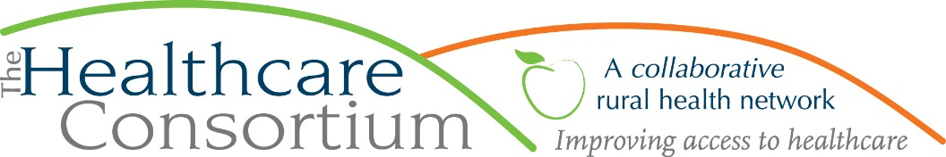
Notes from the Board of Directors Annual Meeting of April 3rd, 2019
Hudson Hall, 327 Warren Street, Hudson

Call to Order
The meeting was called to order by President Robin Andrews at 5:05 p.m.

Roll Call
The following members were present at Roll Call: Robin Andrews, Beth Schuster, James Campion, Michael Cole, PJ Keeler, Theresa Lux, Jack Mabb, Jeff Rovitz, Laurie Scott, Sarah Sterling, Scott Thomas, John Thompson, and Linda Tripp.

The following members were absent at roll call: Robert Gibson, Chelly Hegan, Kevin McDonald, Art Proper, Tina Sharpe, Ken Stall, Nancy Watrous

Robin Andrews, President of the Board of Directors, offered a welcome and brief remarks. She then introduced Linda Tripp, Chair of the Governance Committee.

Nomination and Election of Board Members
Linda Tripp presented the following slate of candidates for re-election to the Consortium’s Board of Directors:

- Michael Cole, Columbia County Department of Human Services
- Robert Gibson, Columbia County Department of Social Services
- PJ Keeler, Columbia County Treasurer and EMS Coordinator
- Theresa Lux, Catholic Charities
- Jack Mabb, Columbia County Department of Health
- Kevin McDonald, Columbia County Office for the Aging
- Jeffrey Rovitz, Mental Health Association of Columbia/Greene Counties
- Laurie Scott, ReEntry Columbia
- Scott Thomas, as a non-designated member
- Linda Tripp, Cooperative Extension of Columbia/Greene Counties

Linda Tripp requested a motion to reelect the slate of candidates to two-year terms on the Board of Directors.

Be it RESOLVED, the Board of Directors re-elects the aforementioned members to two-year terms on the Consortium’s Board of Directors.

Motion made by Beth Schuster, seconded by Scott Thomas, and unanimously approved.

Robin thanked the members for renewing their commitment.

Appointment of Committee Chairs
Robin announced the appointment of the Committee Chairs as follows:
- Jack Mabb, Budget and Finance Committee
- Art Proper, Corporate Compliance Committee
- Linda Tripp, Governance Committee
Robin thanked these Directors for renewing their commitment to serving as Committee Chairs.

Presentation of the Anne W. Zittell Friend of the Consortium Award
Robin welcomed Claire Parde, the Consortium’s Executive Director, to the podium to announce that the 2019 recipient of the award is James R. Campion, President of Columbia-Greene Community College and long-standing Board member for whom she provided a short bio. Claire, in turn, introduced PJ Keeler, who spoke about Jim Campion and his work in the community, and presented him with the award.

Claire then invited the following elected officials or their representative staff members to speak about Jim Campion:
- Amanda Boomhower, representing Congressman Antonio Delgado, who presented Jim with a certificate
- Senator Daphne Jordan, who presented Jim with a citation
- Matt Hartzog, representing Assemblymember Didi Barrett, who presented Jim with a citation
- Claire, who presented a citation on behalf of Assemblymember Chris Tague’s office

Closing Remarks
Claire then spoke briefly, thanking Jim for his work with and contributions to the Consortium during his years of service. She thanked all those in attendance.

Adjournment
The annual meeting concluded at 5:45 p.m.

