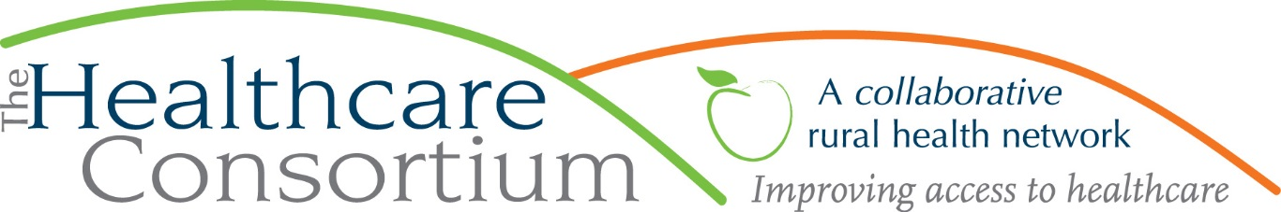

Notes from the Board of Directors Meeting of August 4, 2021

- Call to Order and Roll Call
Due to Covid-19 concerns, this meeting was held virtually on the Zoom web platform. All voting was done contemporaneously using computer audio.

The meeting was called to order by President Robin Andrews at 2:32 p.m.

The following members were present at the call to order: Art Proper, Bob Gibson, Casey O’Brien, Chelly Hegan, Dorothy Urschel, Jack Mabb, Jeff Rovitz, John Thompson, Ken Stall, Kevin McDonald, Raina Cashdollar, Robin Andrews, Scott Thomas, Theresa Lux,

The following members were absent at Roll Call: Dan Almasi, PJ Keeler, Sarah Sterling, Tina Lee

Also present were the following:
Staff members: Claire Parde, John Ray, Karen dePeyster, Lisa Thomas, Ashling Kelly
Guest Speaker: Kelly Radzik

[Dan Almasi entered the meeting at 2:35 p.m.]

- Reminder of Duty to Disclose
Robin requested that Board members remember their duty to disclose any interests that might give rise to a conflict whenever the Board acts.

- Presentation: The New Workforce
Kelly Radzik, Director of Applied Learning and Job Development at Columbia-Greene Community College spoke about “The New Workforce,” including common characteristics and expectations of Millenials and Gen Zers in the workforce.

Highlights from the presentation:
- Millenials were born between 1981 and 1996, but they really consist of two sub-groups: those born in the early part of that time frame, during an economic boom (1981-1987) and those born later, during a recession (1988-1996)
- Gen Zers were born between 1997 and 2010

- Millennials and Gen Zers differ in their workplace expectations around communication preferences, management styles, work/life balance, and job perks.

- Half of Millennials and Gen Zers are reluctant to apply for entry level positions for which they feel unqualified. Prospective employers should consider referring to ‘preferred’ skills and experience for those that are not absolutely necessary to attract more applicants. Additionally, the availability of job training is very attractive to Gen Z applicants.

Kelly will send the slide presentation to Ashling to share with the Board members.

[Kevin McDonald left the meeting at 2:59 p.m.]
[Speaker Kelly Radzik and staff members John Ray and Karen dePeyster left the meeting at 3:27 p.m.]

- Consent Agenda
- Board of Directors meeting minutes of June 2, 2021
- Committee meeting minutes:
- Budget and Finance Committee Meeting of July 27, 2021
- Governance Committee Meeting of July 28, 2021

Be it RESOLVED, the Board of Directors moves to accept the minutes/actions for the Board of Directors meeting of June 2, 2021 and all Committee meeting minutes. [All members may act]

Motion made by Casey O’Brien, seconded by Theresa Lux, and unanimously approved.

- President’s Report

Robin Andrew introduced NY State HERO Act additions to both the Personnel Policy and the C.A.R.T.S. Policy:

Be it RESOLVED, The Board of Directors approves Personnel Policy 1301 and C.A.R.T.S Policy: Airborne Infectious Disease Exposure Prevention Plan. [All members may act]

Motion made by Bob Gibson, seconded by Jack Mabb, and unanimously approved.

- Treasurer’s Report
Treasurer Jack Mabb reported that the agency had transferred $100,000 into the investment account, which now has a balance of approximately $340,000.

The PPP loan forgiveness application is currently being reviewed by Bonadio.

The Consortium is talking with Enterprise Fleet Management regarding leasing Transportation program vehicles.

- Executive Director’s Report
A written report from the Executive Director was emailed to Board members prior to the meeting (see attached). At the meeting, Claire reported that the Consortium is one of the Foundation for Community Health’s three grantees for general operating support. This is a new experiment for FCH in trust-based philanthropy; Claire described the relationship with FCH as a partnership. The grant is $100,000 per year for three years, with the first installment to be received this Fall. Claire reported that after meeting with FCH staff about her initial ideas for utilizing the funds, they shared that she seemed to have a much more developed plan than other grantees. Claire attributed this to the existence of the Strategic Plan, which provides her with a very clear guide, and expressed her gratitude to the Board for developing it. It has aided her in setting, focusing on, and completing specific Plan goals. One of the items in the Strategic Plan is “strengthening the workforce and ensuring competitive salaries.” To that end, Claire is on the cusp of bringing the staff up to or very near their 2021 compensation targets. This is a market adjustment to raise wages to a competitive level. As a result, the annual cost of living increase, which has historically been 3%, will likely be closer to 1% in the future. While wage increases are limited by contract funding, Claire would consider supplementing wages with the additional funding monies coming in, should market changes indicate a need for adjustment.

The contract with Roya Consulting for development services is going well; Claire is meeting with Michele Susko monthly. Michele has encouraged Claire to reach out to foundations with which she has worked before to determine if future funding is an option.

- Discussion
Current Board mentors Casey O’Brien, Chelly Hegan, Jeff Rovitz, and Robin Andrews formally introduced their respective Board mentees Dan Almasi, Dorothy Urschel, Tina Lee, and Raina Cashdollar.

- Adjournment
The business of the Board being concluded, the meeting was adjourned at 3:51 p.m

Respectfully Submitted,

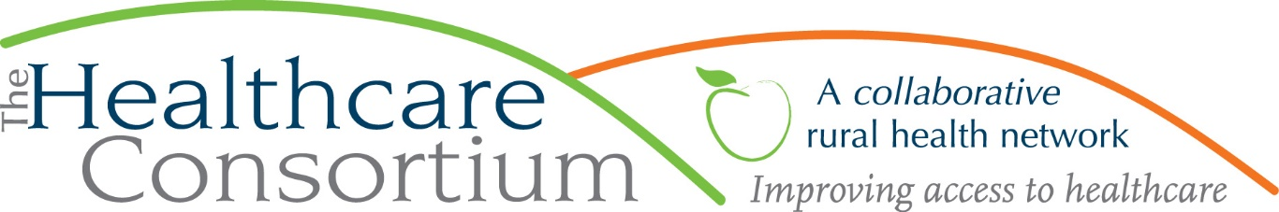
Executive Director’s Report to the Board, August 4, 2021

Contract Management
New York State Contracts
- TOB--We continue to wait for our current year budget and work plan (that is, the one beginning on July 1, 2020 and ending June 30, 2021) for the Tobacco Control contract with NYSDOH to be approved. Because there was significant uncertainty with regard to this contract for an extended period of time, we allowed positions to remain vacant and reduced other-than-personnel expenses. Given that the budget is not approved, even at this late date, this year’s budget amount will be significantly underspent.
We assume that once the current year budget is approved, we will then be asked to develop the budget and work plan for the next contract year—that is, the one beginning July 1, 2021 and ending June 30, 2022.
- NAV—We submitted the budget and work plan for the current year of the Navigator Program contract with NYSDOH, which begins on August 1, 2021 and ends July 31, 2022, and are awaiting approval. As is customary, we do not affect annual increases to wages for contract staff until after such time as the budget has been approved.
County Contracts
- We now have an executed agreement with the Columbia County Office for the Aging for the NYConnects Program, which began on April 1, 2021 and ends March 31, 2022, and can now submit vouchers for reimbursement of expenses incurred.
- It has become clear that the amount and term of our contract with the Columbia County Department of Health to serve as the fiscal agent for the Community Impact Dollars associated with the Healing Communities Study will have to be amended to increase the amount and extend the term. More on that as it unfolds.
Other Contracts
- In partnership with a subcontractor, SWB Consulting Services, we have been consulting, on a contractual basis, with Coarc to facilitate a 14-month long strategic planning process. Not unlike our contract with CMH to oversee the community health assessment, planning, implementation, monitoring and reporting processes, this is an example of a fee-for-service approach to generating revenue for the Consortium, with a focus on delivering services that are needed by and benefit Network Members.
Resource Development
- I continue to meet on a once monthly basis (July excepted) with the Development Consultant, Michele Susko of Roya Consulting. At her urging, I met with my contact at the Rip Van Winkle Foundation to discuss options for future funding and have been invited to submit a proposal. I have also met with the Berkshire Taconic Foundation to better acquaint them with the Consortium and its work and better understand their funding priorities. It was a fruitful discussion and a second installment has now been scheduled for later this month. Finally, I have approached the Home for the Aged with a request to meet and hope to schedule that shortly.
- Great news! We are delighted to report that the Healthcare Consortium is one of three existing grantees of the Foundation for Community Health (FCH) that has been selected to receive general operating support. FCH has committed to provide the Consortium with $100,000 per year for the next three years, with exactly zero constraints on how the money is to be expended. This represents a shift in FCH’s funding strategy from program-based funding to general operating support in the interest of advancing trust-based philanthropy (https://www.trustbasedphilanthropy.org/). It also represents a greater level of investment in their New York service area, which has greater need than in Connecticut.
- Happily, FCH’s commitment to provide general operating support will not impact its historical program funding to the Consortium, and we have been invited to submit an application for transportation program support, as we do each September

Personnel Management
- Our new staff members are settling in nicely. We anticipate that Elaine Allen will return from her leave of absence in late August or early September, which will fully restore our team (zero vacancies, no absences).
- In keeping with our strategic initiative of providing staff with competitive compensation, I have budgeted and/or provided for significant wage adjustments that get all staff at or very near their 2021 compensation targets. I am both proud and pleased about what we have been able to accomplish in this regard and think it will be key to achieving our goal of developing and strengthening our workforce.

External Engagement
- I’ve been participating in a small-group, limited-duration effort to update the Columbia County Addiction Response Plan, which I will help to present to the Columbia County Board of Supervisors on August 11th
- I’ve been participating in a small-group, limited-duration effort to determine the future of the Columbia-Greene Addiction Coalition; that work is ongoing
- I’ve joined the Fatality Review Board that will review deaths related to Behavioral Health (overdoses, other substance use, completed suicides etc.) with the goal of identifying gaps, challenges and barriers within our system
- I continue to convene and facilitate meetings of the Southern Hub Behavioral Health Workgroup, which meets once monthly
- I have recently joined the Advisory Committee of the Everhome Columbia Project, which aims to marry care coordination and in-home technology to help Columbia County seniors live safely and independently at home.
- I continue to be vetted by the Governor’s Office as a condition of my appointment to the Rural Health Council, which has not yet been fully populated or convened
Upcoming Board and Committee meeting dates
- 9/1 Executive Committee 9:00 am
- 9/1 Corporate Compliance Committee 10:00 am
- 9/28 Budget and Finance Committee 3:00 pm
- 10/6 Board of Directors 2:30 pm

