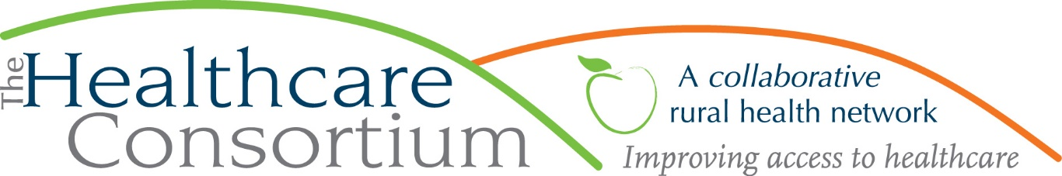

Understanding the Unvaccinated
By Claire Parde, Executive Director

Since the onset of the COVID-19 pandemic, you have probably heard and read about the concept of herd immunity many times. By way of reminder, herd immunity occurs when a large portion of a community (the “herd”) becomes immune to a disease from either past infection or vaccination, making its spread from person to person unlikely. As a result, the whole community becomes protected, not just those who are immune.
Conversely, when a large enough part of the population remains capable of getting the disease, it gives the disease a foothold that allows its continued spread. It is for this reason that the choice not to vaccinate can pose risks that extend beyond the person who remains unvaccinated to the greater community of which they are a part. It gives the virus somewhere to go, and thereby helps it stick around, so even the vaccinated aren’t totally safe from it.
It can be frustrating for people who have embraced our most powerful tool in the fight against COVID-19—the vaccines that, as a result of unprecedented levels of funding and collaboration among scientists around the world, were gifted to us more quickly than we even hoped--to think about people who have not done so. Some of that frustration may spring from a fear of the worst of what infectious disease experts have warned are possibilities: that the virus may mutate into variants that may be resistant to the existing vaccines, that may be more deadly or debilitating in the long term, or that may target populations, like children, that had been largely unaffected before. And, I’ve noticed, some of that frustration is often based in assumptions about who the unvaccinated are and what they think.
I think it would be a mistake to regard those who have chosen not to get vaccinated (as distinguished from those who, for a variety of reasons, cannot get vaccinated) as ignorant and inflexible, selfish and uncaring. While some may be accurately described this way, I do not believe that describes everybody who has chosen to remain unvaccinated, or even most. While it’s natural for the vaccinated to be frustrated with those who aren’t, we must resist the urge to treat all persons who have elected against getting vaccinated like they belong to some homogenous group of the willfully ignorant, ornery, and antisocial. Lumping them in this way not only risks being intellectually lazy and morally superior, it is also notably unhelpful; no one has ever been persuaded to do anything by someone who clearly doesn’t like them.
For my part, I don’t think the purposefully unvaccinated are a uniform group of people with identical circumstances or concerns. In fact, I think they are a pretty diverse group of people, whose reasons for being unvaccinated are as varied as they are. Some of them are hesitant, which is entirely different from being resistant, while others are fearful, which is entirely different from being a fear monger, while yet others are unmotivated, which is entirely different from being opposed. I would argue that these distinctions are meaningful and are exactly what we must strive to understand if we want to “turn” any part of this group into folks who can proudly claim to have, “Got the Shot!”
To be successful in converting the unvaccinated to vaccinated (because we do, indeed, need more people to participate in the vaccine program to achieve herd immunity), we must approach them not with condemnation and contempt, but in the spirit of inquiry. If we want to promote widespread vaccination, then we have to know why someone might have chosen not to be vaccinated (so far). Our questions must be: Who are you? What are your reasons? What would you need to read or hear that would make you feel differently, and from whom? The answers to these questions, if they are both asked and answered honestly, may tell us something useful. At the least, it may tell us something we didn’t already know and thereby improve our understanding.
Perhaps, through honest inquiry, we will unearth concerns that are within our power to address through education and persuasion. We may also encounter concerns that are entirely outside our power to address, like deeply held beliefs that are not likely to change. Either way, I believe there is value in asking, listening, learning, and understanding, both for the current crisis and public health response, and for the future of informed and compassionate public health practice in general.
***
The Healthcare Consortium is a local charitable organization with a mission of improving access to healthcare and supporting the health and well-being of the residents in our rural community. The agency is located at 325 Columbia St. in Hudson. For more information: visit www.columbiahealthnet.org or call 518-822-8820.

