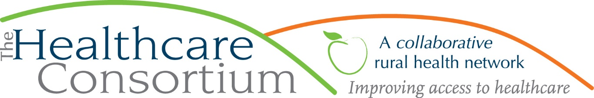

COVID, Stress & Smoking
by Karen dePeyster
Tobacco-Free Action

COVID-induced upheaval has caused a lot of stress to a lot of people, many of whom were already burdened by the pressures of daily life. Normal routines disrupted, financial worries, health concerns, isolation, exhaustion and uncertainty have all taken their toll on mental health.

Addictive behavior is often triggered by anxiety and boredom; it’s not hard to understand why in the last year and a half alcohol consumption, substance abuse and smoking have all increased. In troubled times, people tend to rely on familiar ways of coping, whether they are healthy or not, as long as they provide at least some temporary relief or distraction. (It’s worth noting that overeating has also been “weigh” up and that online shopping is off the charts; when it comes to compulsive behavior under stress, there’s something for just about everyone.) For those in recovery, distress can quickly lead to relapse, which has increased as well.

Early on after the outbreak began, the CDC sounded a warning that smokers were at greater risk of severe illness if they contracted COVID-19, a respiratory virus. This is because smoking damages lung function and weakens the immune system’s capacity to fight infection. The CDC message seems to have hit home; studies show that nearly 70% of smokers believed that the warning was true. Up to 40% expressed a stronger desire to quit.

Yet smoking actually increased. After dropping by 4-5% each year since 2015, cigarette sales in the U.S. rose by 1% in 2020. The number of people calling toll-free cessation helplines fell by 30% to the lowest number since 2007. While the majority of smokers reported no change in consumption, up to 25-30% smoked more. Between 12%-23% say they smoked less.

For those who smoked less a primary motivating factor was feeling that COVID was not just a greater risk for smokers in general, but an imminent and dangerous threat to them as an individual. The stronger the perception of one’s own susceptibility and vulnerability, the stronger the resolve to reduce personal risk. In this case, stress was caused by the fear of getting deathly sick from COVID and led to positive action. Environmental factors, such as spending less time in social situations that promote smoking, parents spending more time with their children, and difficulty affording cigarettes were also reasons that led to decreased smoking.

For those who smoked more, anxiety, boredom and depression were more powerful stressors. In the words of Linda Bailey, CEO of North American Quitline Consortium, “This past year was just not the time when people thought they had the emotional strength to really fight cravings.” You don’t have to be a smoker to fully appreciate the truth of this statement. Which of us at some time during the pandemic has not found our own emotional strength fraying?

It’s not only adults who have been affected by stress in the last year and a half. The Truth Initiative recently released a report outlining concerns that levels of anxiety and depression among young people were already high pre-pandemic and that a significant number of them are vaping as a way to cope with these feelings. It is true that the nicotine in e-vapor provides a pleasurable sensation that may be equated with relief, but because the nicotine content in many vaping liquids is so concentrated and delivered so smoothly, it is deceptively easy for dependence to develop quickly. Once that happens, the symptoms of withdrawal—irritability, restlessness, agitation—mimic the very same feelings that the user was trying to escape from. In this way, vaping makes it more difficult to effectively treat the underlying mental health conditions that were the original cause of distress and may even make those conditions worse. Especially for teens and young adults most affected by the social and educational disruptions of the past year and half, vaping is part of the problem, not part of the solution.

Now that so many of us are vaccinated and students are back in school buildings, daily life is slowly edging back toward normal, but it will take a long time to fully recover from the effects COVID has had on our physical, emotional and societal well-being. Stress will always be with us; getting it back to more manageable levels is something we can all look forward to.

***
The Healthcare Consortium is a local charitable organization with a mission of improving access to healthcare and supporting the health and well-being of the residents in our rural community. The agency is located at 325 Columbia St. in Hudson. For more information: visit www.columbiahealthnet.org or call 518-822-8820.

