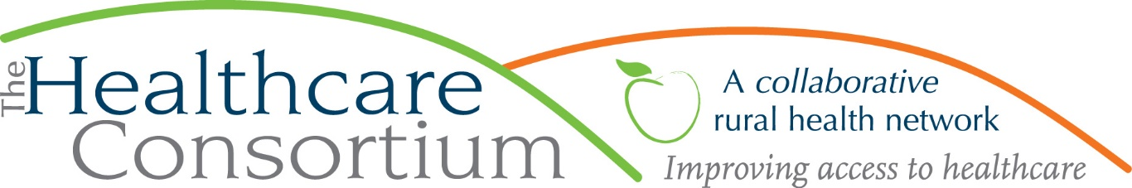

The 5 A’s of Access
By Claire Parde, Executive Director

Earlier this fall, the Healthcare Consortium was part of a group that surveyed residents of Columbia and Greene Counties to identify the most serious public health problems in our community. Among a range of issues, mental illness (including suicide) was identified as “very serious” by 43.0% of the people who responded. When respondents were then asked to identify what kind of health services they would like to be more available in their community, 71% indicated that they would like more mental health services.
Furthermore, 4.5% of those who responded indicated that they had needed to see or speak with a mental health professional (e.g. a psychologist, psychiatrist, psychiatric nurse or clinical social worker) about their health in the past 12 months but were unable to do so. When asked about the reasons for this, the responses were varied, but the most frequently cited reason for not getting mental health care when needed is that providers are full and not accepting new patients or have long waiting lists. In short, the survey confirmed what we already knew from other sources: there are just not enough mental health providers in our community and that has a direct effect on access to care for at least some of our residents.

While we often think of “access” to healthcare services in financial terms—that is, whether or not someone has the health insurance coverage or cash on hand to pay for those services—that is, in fact, a fairly narrow way to define access. In our work at the Consortium, we try to think about access in a broader way, and find the framework called the “5 A’s of Access”, developed by R. Penchansky and JW Thomas in the early ‘80’s, very useful. The “5 A’s” refer to five words that describe the multiple dimensions of access: affordability, availability, accessibility, accommodation, and acceptability. Let’s examine each of these terms:
- Affordability describes the relationship between the costs of seeking healthcare services--including a healthcare provider's charges for a healthcare service but also things like the costs of transportation, childcare, and lost work time and income to attend a healthcare appointment--and a patient’s willingness and ability to absorb those costs.
- Availability describes the extent to which a healthcare provider has what they need, such as staff and technology, to meet the needs of the patient in a comprehensive and timely way. This term can also be extended to the healthcare system as a whole, and whether it has the right type of services and enough of them to meet demand.
- Accessibility refers to how easily the client can physically reach the healthcare provider's location. This really is about the geographic distance between provider and patient and whether and how easily that distance can be travelled.
- Accommodation reflects the extent to which the healthcare provider’s operation is organized in ways that meet the constraints and preferences of the client. This includes things like days and hours of operation (e.g. do they have weekend and evening hours?), how communications are handled (e.g. do they use email or the web for scheduling and consults?), and the patient’s ability to receive care without prior appointments (e.g. are there same-day or walk-in appointments?).
- Finally, Acceptability captures the extent to which a patient is comfortable with various characteristics of the healthcare provider, and vice versa. These can be characteristics such as age, sex, gender, race/ethnicity, social class, type of health insurance coverage, and even diagnosis.
As you can see, access is actually a pretty complex concept, but it is useful to break it up into parts to see whether, as individual providers or as a whole system, we “hit all the marks.” Evaluating a program, service or system against all 5 A’s also reveals something else: access is only as good as its weakest link, which the example of mental health services proves well. There are mental health providers in our community who have made great efforts to address many aspects of access by doing things like offering a sliding fee scale to ensure their services are affordable to all, by creating satellite sites throughout the area to ensure their services are accessible, and by making accommodations like evening and walk-in appointments. Nevertheless, we struggle with other aspects of access, including and most notably, availability. In short, a provider or system can do everything else “right” but until there are enough mental health providers to see all the patients who have a need, it will continue to have a problem of access.

***
The Healthcare Consortium is a local charitable organization with a mission of improving access to healthcare and supporting the health and well-being of the residents in our rural community. The agency is located at 325 Columbia St. in Hudson. For more information: visit www.columbiahealthnet.org or call 518-822-8820.

