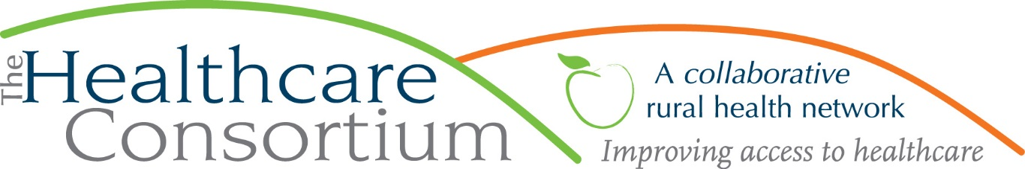

CARTS – On a Mission to Help You
Jim Funk – Transportation Program Coordinator

The Columbia County Community Healthcare Consortium is a not-for-profit organization whose mission is improving access to healthcare and supporting the health and well-being of the people in our rural community.
In 1999 the Healthcare Consortium created the Children and Adults Rural Transportation Service, or CARTS. The program was developed to respond to the need of many Columbia County residents for transportation to and from medical appointments. Since its inception, the CARTS Program has provided nearly 4000 Columbia County residents with more than 200,000 rides to their medical appointments, covering more than 2,400,000 miles.
The COVID-19 pandemic has devastated our community, but the CARTS program has continued to serve our clients throughout this challenging time. From April 1, 2020 to March 1, 2022, our dedicated drivers provided more than 630 Columbia County residents with more than 18,500 rides to their medical appointments, covering more than 274,500 miles, despite the potential risks to themselves.
Lack of transportation is a significant barrier to healthcare access. Often, providers change locations; if a patient wishes to remain with that provider they must travel a greater distance. Someone may need to see a specialist, who practices out of the area. Sometimes, an individual lacks a vehicle, or the financial resources to maintain a car, put gas in it, or pay tolls. And for some, the ability or willingness to drive greater distances diminishes due to age, injury or illness. Our Transportation program exists to improve Columbia County residents’ access to healthcare, and support their health and well-being by getting them to the healthcare providers they need.
Any Columbia County resident with a need for non-emergency medical transportation is eligible to receive this service; there are no other eligibility criteria. The service is door-to-door, meaning that a CARTS driver will escort an individual from the threshold of their home or other pickup location to the threshold of a healthcare provider’s office (anyone needing a greater level of assistance should be accompanied by a family member, friend, or aide). Our service retrieves individuals from any location in Columbia County, and delivers them to locations throughout the county, and well beyond it. CARTS regularly provides rides to healthcare providers in Albany, Catskill, Kingston, Pittsfield, Great Barrington, and Sharon, CT, as well as other locations.
There is no charge to take advantage of this service. We do not bill your health insurance, and you do not have to be receiving Medicaid benefits to be eligible for transportation. Those clients who are enrolled in Medicaid must call 1-855-360-3546 to confirm eligibility for transportation and receive prior authorization for the trip. During this call, people are encouraged to request the Healthcare Consortium as the preferred provider for transport. While there is no guarantee that the Healthcare Consortium will provide the trip,
making a request for us by name will ensure that we are given the option to do so. Donations are always welcome and greatly appreciated, but your transportation is not affected by your willingness or ability to donate.
CARTS operates a well-maintained, smoke-free fleet of 11 vehicles which includes minivans, sedans, and our multi-passenger wheelchair-accessible minibus. Our drivers are courteous, friendly, and professional.
Our hours of operation are 8:00 a.m. to 4:00 p.m., Monday through Friday, excluding holidays. Our scheduling is done on a first-come, first-served basis, so it’s important to call our office as soon as a medical appointment is made to ensure your transportation needs can be met. It is not unusual for us to be scheduled two weeks in advance for in-county trips, and longer for out-of-county trips, so contacting us as soon as you make your appointment is key to making sure your transportation needs can be met.
If you are a Columbia County resident having a difficult time getting to a medical appointment, contact the Healthcare Consortium at (518) 822-8020. We are here to help you take care of you.
***
The Healthcare Consortium is a non-profit organization with a mission of improving access to healthcare and supporting the health and well-being of the residents in our rural community. The agency is located at 325 Columbia St. in Hudson. For more information: visit www.columbiahealthnet.org or call 518-822-8820.

