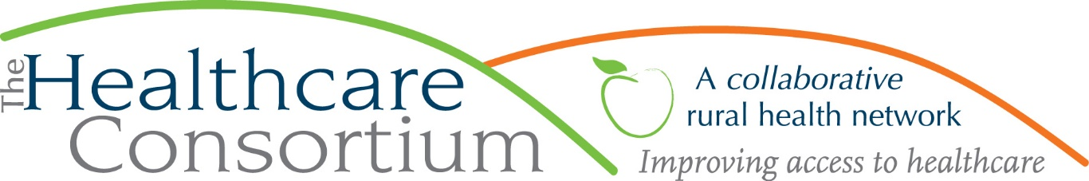

In Our New World, Broadband is No Longer Optional
By Claire Parde, Executive Director

If COVID taught us anything, it is that broadband is not optional.

For years, healthcare and public health advocates have been arguing that high-speed internet—broadband--is vital if we want to expand the use of telehealth services—that is, services provided virtually, by telephone and/or video. This was felt to be a particularly important option for residents of rural areas, where patients are often forced to travel significant distances for their healthcare appointments, and also where there are often fewer healthcare providers, including specialists of all kinds. Telehealth offers the potential for patients to meet with providers regardless of their location, and perhaps even access specialized services that would otherwise be unavailable in their immediate area.

When the pandemic descended on the United States last March, the argument that broadband is essential for healthcare was immediately bolstered, as in-person healthcare appointments were cancelled or deferred by both healthcare providers and patients alike, and telehealth appointments rose dramatically. While the resumption of in-person visits may have lessened the demand for telehealth services, they are nevertheless expected to remain one among a menu of options for interacting with the healthcare system in the future.

In fact, this experience has reinforced the idea that broadband truly is another “social determinant of health”—that is, a factor that influences the health of an individual and even a whole community. Like poverty, housing, transportation, and other features of a person’s life and environment that have profound effects on whether or not that person can get and stay healthy, we can now safely count having access to broadband as critically important to creating and maintaining individual and community health.

COVID also proved that broadband is essential for other reasons as well. During the initial lockdown and in the months since, broadband allowed those workers who could work remotely to do so. It also allowed students to learn remotely and businesses of all sizes to continue to function. For what feels like the first time, there is widespread acknowledgment from multiple different sectors and stakeholders that broadband is no longer just something that’s “nice to have’; instead, it’s a “must-have”…for health, employment, education and economic development. As Deputy Greene County Administrator Warren Hart was recently quoted to say, “High-speed broadband has become as essential as water and electricity for a good quality of life.”

Happily, this widespread acknowledgment that broadband is essential is currently being reflected in work such as the Greene County New York Broadband Availability and Adoption Initiative, which is starting its work with a survey to assess the availability and reliability of internet service in Greene County (visit https://www.greenebroadband.com/ or call 518-719-3270 to get the survey), and also in legislation, such as NYS Senator Michelle Hinchey’s initiative to make broadband expansion more affordable for rural broadband providers. It seems that leaders at all levels have simultaneously agreed that broadband is no longer optional, but rather the foundation on which this new world of healthcare, employment, education and economic activity needs to rest.

***
The Healthcare Consortium is a local charitable organization with a mission of improving access to healthcare and supporting the health and well-being of the residents in our rural community. The agency is located at 325 Columbia St. in Hudson. For more information: visit www.columbiahealthnet.org or call 518-822-8820.

