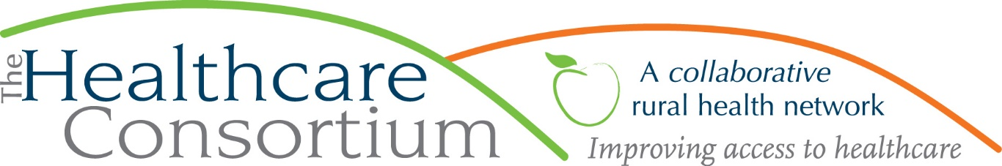

No Menthol Sunday is May 15th

By Karen dePeyster
Tobacco-Free Action of Columbia & Greene Counties

When the Food & Drug Administration (FDA) announced a year ago that it was intending to ban the sale of menthol cigarettes and other flavored tobacco products, among those cheering loudest were advocates from the Center for Black Health & Equity, which has lobbied against menthol for more than twenty years. The Center sponsors No Menthol Sunday every year in mid-May as a way to raise awareness about how menthol became the cigarette of choice for 85% of Black smokers (it’s not by accident) and what a heavy toll it takes. Smoking-related illness – heart disease, lung cancer, stroke – is the leading cause of death among African-Americans, claiming 45,000 lives annually.

The FDA announcement last year was based on science and the interests of public health, but like all matters played out in an arena where politics and money operate freely, it is not a guarantee. There are many steps before a legal ban can be made official, and plenty of opportunity along the way for delay or derailment. In 2009, when the FDA was first given authority to regulate tobacco, its first act was to ban flavored cigarettes; menthol was exempted, precisely because of the interplay of politics and money. With that disappointment in mind, the Center has made the theme of this year’s No Menthol Sunday one of determination and resolve: “Fight to the Finish.”

In the 1950’s, only 5% of African-Americans who smoked were menthol users. The tobacco industry, seeing dollar signs in the growth potential for this market, set out on a calculated, well-financed campaign to cultivate a strong customer-base in Black communities by finding every possible way to associate their menthol brands—Kool, Salem, Newport—with Black culture.

In his recent book “Pushing Cool,” Keith Wailoo, Professor of History and Public Affairs at Princeton University, describes this strategy as “predatory,” racial marketing” and “blaxploitation.” Unfortunately, cynical profiteering is often a winning formula. By 1968 the proportion of Black smokers who used a menthol brand had climbed to 14%; then it rose by startling increments to 42% in 1976 and 80% by 2000.

Of course, menthol, with its minty taste and cooling sensation, also has widespread appeal among all groups of smokers, especially teens and young adults. The popularity of menthol brands rose sharply after other flavored cigarettes were banned by the FDA in 2009 and continues to increase, now accounting for almost 40% of the market. Last summer, staff from our program conducted observations in all stores that sell tobacco in Hudson and the surrounding Town of Greenport. Every one of them said that their best-selling cigarette is Newport. Twenty years ago, or maybe even ten, the answer for most would have been Marlboro.

For menthol ban advocates, the bottom line is saving lives and improving health. Smoking remains the leading cause of preventable death and disease in the nation, even as smoking rates have decreased. In a 2011 report detailing its findings on menthol cigarettes, the FDA concluded that they are more addictive, create more dependence, and are harder to quit than unflavored brands. The report estimated that a menthol ban would cause 39% of all menthol smokers and 47% of African American menthol users to quit, and prevent 2.3 million new youth smokers within 10 years.

On April 28, a full year after its initial announcement, the FDA formally published two proposed regulations, the first to ban menthol cigarettes; the second to ban flavored cigars. It will likely take another year for multiple layers of comment, review and revision to be completed. At every step tobacco lobbyists will be trying to disrupt the process. After the regulations are finalized, lawyers for the tobacco companies will almost certainly sue in an attempt to prevent them from going into effect. The fight is not over yet.

But for now, on May 15th the Center for Black Health & Equity and its many allies will be celebrating what they hope is the beginning of the end for menthol cigarettes, and urging the public to be vocal in its support. For more information on No Menthol Sunday and on how to submit comments on the proposed FDA rules, go to: www.centerforblackhealth.org ; www.savingblacklives.org ; or, www.tobaccofreekids.org.

***
The Healthcare Consortium is a local charitable organization with a mission of improving access to healthcare and supporting the health and well-being of the residents in our rural community. The agency is located at 325 Columbia St. in Hudson. For more information: visit www.columbiahealthnet.org or call 518-822-8820.

