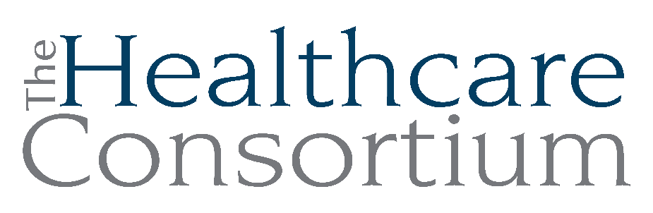
Notes from the Executive Committee meeting of May 7, 2025

Note: This meeting was held virtually on the Zoom web platform

Attendance
Committee Members: Art Proper, Jack Mabb, Becky Polmateer, Maria Ostrander, Karen Amanna
Absent Committee Members: none
Staff Members: Claire Parde, Lisa Thomas

Claire welcomed Karen and Maria to the Executive Committee and thanked them for their willingness to serve as Officers of the Board.

General Updates

- Audit

Claire reported that the Audit is well underway. The preliminary work occurred in February and the “field work” is happening now, which includes a lot of questions and submissions. We are currently on track to present to the full Board in June.

- QuickBooks

Claire reported that we will be migrating from QuickBooks Desktop to Quickbooks Online for our accounting software and payroll service. In anticipation of this, we have been making frequent contact with customer service representatives at Intuit, the company that makes Quickbooks, which has been extremely frustrating. The migration is planned for the week of May 12th, chosen because we do NOT issue pay in that week. The hope, of course, is for the transition to be a smooth one, but the Admin Team is assuming that there will be a certain amount of “lumps and bumps” and has planned accordingly.

- NY Connects Greene County

Greene County Department of Human Services (GCDHS) has subcontracted with the Consortium to run NY Connects in Greene County. The contract started on April 1st and is for $180,000. We have hired Ashling Kelly, a former employee, as a full-time Information & Assistance Specialist, who is embedded in Greene County every day of the week. Kathleen Coffey, our new Director of Programs, spends two days per week in Greene County. The startup has gone rather smoothly. Claire and Kathleen have arranged for biweekly meetings with GCDHS’ Leadership Team, and they are going well.

This new contract advances one of our strategic plan goal of Preserving and Enhancing Our Core Functions by growing our portfolio of direct services in Greene County and cementing our working relationships there as well.

- Hiring

We continue to interview candidates for the Navigator Program since we anticipate the departure of our part-time Navigator, David Leacock, on Friday, May 9th. Full-time Navigator Emi Davenport has returned from maternity leave but is primarily remote due to childcare issues.

- Transportation

The Consortium has been working with the Transportation Planning Committee of Columbia County to add a route from Chatham to Hudson on Tuesdays and Fridays as well as a shuttle from Chatham to New Lebanon and Canaan. The goal is to reduce social isolation of seniors and serve the homeless population at Berkshire Lodge. Claire submitted a proposal to provide the shuttle service on May 1st and is currently awaiting feedback. Claire feels this is a great opportunity to be helpful to the County. Columbia County provides us with a lot of support, including in-kind office space. Claire wants to continue to demonstrate our value and be a good partner. However, it is not yet clear if the Consortium would be eligible to deliver the service, which depends on whether drivers and vehicles will be subject to DOT regulations.

- Prevention Agenda

The Consortium is now coordinating the Community Health Needs Assessment (CHA) & Community Health Improvement Planning (CHIP) processes for Columbia and Greene Counties, which are related to the State’s Prevention Agenda for 2025-2030. The CHA is well underway; currently, we are planning for two community partner meetings, which will be identical in content, for the month of May. At these meetings, we’ll share data about the health status of the Twin County community, and ask community partners for their input and insights. Thereafter, we’ll start the planning process. Since the new Prevention Agenda is focused on the social determinants of health, the planning process will likely engage with new “untraditional” partners working on topics like housing and education.

- Contract with Healthy Alliance

Due to staffing challenges, the contract with the Healthy Alliance is on hold. We still have the contract documents, but once we decide to start, training begins, which is quite time-consuming. Other Board members shared that they declined to participate.

Next meeting
The next meeting of the Executive Committee will be on July 2, 2025 at 9:00 a.m. via Zoom.

