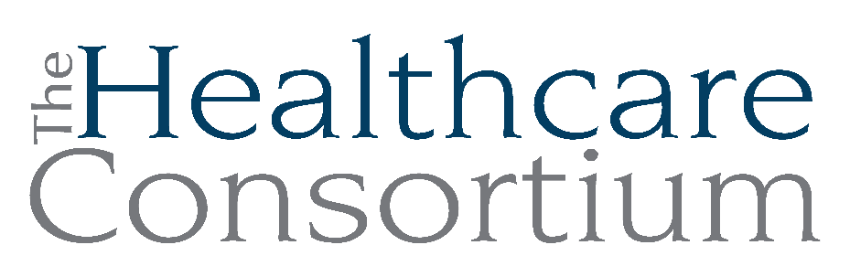

Notes from the Board of Directors Meeting of June 4, 2025

I. Call to Order and Roll Call
This meeting was held virtually on the Zoom web platform. All voting was done contemporaneously via computer audio.

The meeting was called to order by Vice President Becky Polmateer at 2:33 p.m.

The following members were present at Roll Call: Dan Almasi, Nina Benvenuto, Toni Carroll, Bob Gibson, Theresa Lux, Jack Mabb, Victoria McGahan, Marielle McKasty-Stagg, Becky Polmateer, Jolene Race, Aislinn Smith, Kathleen Eldridge.

The following members were absent at roll call: Karen Amanna, PJ Keeler, Maria Ostrander, Amanda Pierro, Art Proper, David Rossetti, John Thompson, Dorothy Urschel.

Also present were staff members Claire Parde, Greg Pettyjohn and Lisa Thomas.

II. Service Story

Prompted by the Governance Committee, Service Stories are brief anecdotes that are meant to illustrate the nature of the Consortium’s work and its impact on our clients. Claire provided an overview of service delivery in the month of May through the Columbia County NY Connects Program to illustrate the types of needs with which clients present.

[David Rossetti entered the meeting at 2:39 p.m.]

III. Reminder of the Duty to Disclose
Becky reminded the group to please remember their duty to disclose any interests that may give rise to a conflict. No disclosures were made at this time.

IV. Consent Agenda
The Board considered the following meeting minutes:
- Board of Directors Meeting of April 2, 2025
- Board of Directors Annual Meeting of April 2, 2025
- Executive Committee Meeting of May 7, 2025
- Corporate Compliance Committee Meeting of May 7, 2025

The motion to accept the minutes/actions of the regular and annual Board of Directors meetings of April 2, 2025, and all Committee meeting minutes was made by Jack Mabb, seconded by David Rossetti, and unanimously approved.

V. Treasurer’s Report
Jack Mabb reviewed the Fiscal Highlights Report. He noted that the Budget and Finance Committee did not meet this month due to the audit and ongoing issues with QuickBooks.

Karen Amanna arrived at 2:41 p.m.

Claire noted that cash is a bit lower due to an increase in accounts receivable. There is a delay in vouchering with the Navigator Program at the request of the contract manager. We should be caught up by the end of June. In addition, we are unable to voucher for RHN until the budget and workplan are approved.

VI. President’s Report
There were no items to report on at this time.

VII. Executive Director’s Report
Claire provided verbal highlights from her more detailed written report:
Audit:

We are nearing the end of the financial audit. The Bonadio Group is working on financial statements. They are having staffing issues, and a key member of our audit team left their employment abruptly. It has been a time-consuming process. Greg has worked hard at responding to all requests in a timely manner.

QuickBooks:

The conversion from Quickbooks Desktop to Quickbooks Online has been very challenging. There are issues with payroll, including Intuit withholding $7400 in taxes we already paid. Their customer service has been very difficult to work with. The good news is that staff are being paid on time.

Greene County NY Connects:

The start-up has been running smoothly since April 1st. Claire and Kathleen meet with Greene County Leadership every other Tuesday to establish relationships and support program implementation. We have welcomed back a former employee, Ashling Kelly, as the new Information and Assistance Specialist.

[Mike Vollmer arrived at 2:59 p.m.]

VIII. Communication/Board Discussion

- Presentation on Audited Financial Statements, Mike Vollmer, The Bonadio Group

See attached audit presentation.

- The audit is substantially completed; needs final review of financial statements by a second partner
- Summary – no significant changes to the plan; no independence matters since last meeting; the plan is to issue an unmodified opinion
- Key Events and Transactions Affecting the Year – continued renewal of state-funded grants and the continuation of the Mother Cabrini Health Foundation grant
- Identified Misstatements, Recorded and Unrecorded – no adjustments were material to the financial statements
- Internal Control Findings – no material weaknesses or deficiencies
- Nothing found which would be a fraud risk
- Trend Analysis – investments are up $50k in 2024; property and equipment decreased due to depreciation; leases are down as none were added; liabilities are up a bit due to timing; accrued expenses are down due to when the 401(k) contributions were expensed
- Revenue is down due to the loss of Foundation for Community Health operating support and the loss of the Tobacco Control Program.
- The current ratio is consistent.
- Accounts receivables are on the high side, which is just a function of how the grants operate.

[Dan Almasi exited the meeting at 3:14 p.m.]

- Executive Session

The motion to enter Executive session was made by Theresa Lux, seconded by David Rossetti, and unanimously approved.

[Staff members Claire Parde, Lisa Thomas and Greg Pettyjohn exited the meeting.]

The motion to end Executive session was made by Bob Gibson, seconded by Jack Mabb, and unanimously approved.

[Staff members Claire Parde, Lisa Thomas and Greg Pettyjohn rejoined the meeting.]

- Motion to Approve the External Audit

The motion to accept the audited financial statements was made by Karen Amanna and seconded by Bob Gibson. Nina Benvenuto and Victoria McGahan abstained as they are not Independent Directors.

In a few weeks, the IRS Form 990 will be sent via email for review and will be filed if there are no issues.

[Mike Vollmer exited the meeting at 3:25 p.m.]

IX. Community Health Assessment and Health Improvement Planning

Claire provided an overview of the Consortium’s role facilitating the work of the Columbia-Greene Planning Partners—that is, the Columbia County Department of Health, Columbia Memorial Health, and Greene County Public Health—to complete the Community Health Assessment and Community Health Improvement Plan. This work is a key feature of the RHN plan of work and is further supported by contractual relationships with each organization.

The Partners are working collaboratively to submit a joint Community Health Assessment and Plan for the Twin Counties, as they have done in the past. The Healthy Capital District (formerly the Healthy Capital District Initiative) completes the data analysis and regional Community Health Needs Assessment. Many health issues were considered, including addiction to drugs and alcohol, asthma, cancer, heart disease and stroke, hunger and food insecurity and so on. Cancer is newly ranked very high.

A publicly available data report can be found on Tableau Data dashboard for Columbia and Greene Counties with information that could be useful when preparing grant applications. Claire will send out the link as well as other resources for locating data.

Victoria commented that Claire is a great partner and the perfect person to do this work.

X. Other discussion

- Interagency Connections Day is Wednesday, June 18th at Columbia Greene Community College; reach out to Becky if interested

- Claire will be sending out a communication to all Network Members to create an inventory of real and potential federal funding cuts. Things are happening and they should be cataloged.

XI. Adjournment
The business of the regular Board meeting being concluded, the meeting was adjourned at 3:57 p.m. following a motion made by Karen Amanna.

Respectfully submitted,

Maria Ostrander, Board Secretary

