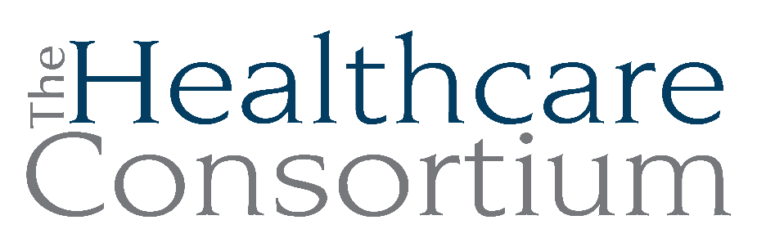
Notes from the Executive Committee meeting of September 3, 2025

Note: This meeting was held virtually on the Zoom web platform

Attendance
Committee Members: Art Proper, Jack Mabb, Becky Polmateer, Maria Ostrander, Karen Amanna
Absent Committee Members: none
Staff Members: Claire Parde, Lisa Thomas

General Updates

- Technology Transitions
Claire reported that we are preparing to replace most of the agency’s computer hardware, many of which are 7 to 10 years old, in advance of the transition to Windows 11 occurring on October 14th. We anticipate an expense of approximately $30,000.

- QuickBooks Payroll Service
Claire reported that we continue to have issues with this product, which is frankly terrible. We will actively pursue moving to a new payroll service and are currently reviewing a number of options (eg. Gusto, Paychex, ADP, etc.)

- Operations
We have had two vacant offices in our office suite since we ended the Tobacco Control Program. Recently, Navigator staff have moved into them. It’s nice to have life in them again, and the move was very much appreciated by staff (who now have windows).

Claire is scheduled to meet with Brian McDonald from Facilities to discuss modifications to a portion of the office suite to prepare the space for the return of the CARTS Program Team to 325 Columbia Street.

- Staffing
Mariana “Emi” Davenport, former Navigator, separated on August 25th. We had allowed for a largely remote work arrangement, but we had to end it because her absence from the office created a negative effect on clients, and undermined our ability to meet contract deliverables.

We hired a new full-time and fully present Navigator, Rosalva Flores, on August 25th. She speaks fluent Spanish.

We continue to advertise and interview candidates for the Navigator Program. We hope to hire another full-time person this fall.

- Transportation
Claire expressed surprise and disappointment that the Mother Cabrini Health Foundation did not invite us to apply for a third year of support, which we had anticipated being able to do. The CARTS Team is meeting frequently this fall to figure out how to manage without the third and final installment of $125,000 that we had anticipated. All ideas are on the table, including reducing trips, charging fees, or imposing eligibility criteria. The team will be taking a strategic design approach to solving this problem but it begins with a recognition that we will need to change the business model to make the program sustainable.

One area that requires focus is accessing major donors in the county. Sydney Keiler, Director of Development and Communications, hasn’t really gotten much traction on this, probably because she lives outside of the area and doesn’t really know the community. Claire suggested creating a Committee of the Corporation and inviting Board members and non-Board members to join to provide guidance and support. Claire asked Becky for permission to add this discussion to the agenda for the October Board meeting, to which Becky agreed.

Board members suggested Claire reach out to Rob Lagonia, who is very connected with donors, as well as Joan Koweek and Jack Shear.

- Audit
Claire reported that IRS Form 990 is still in process. All information is in to the Bonadio Group. It will likely take a couple more weeks.

We will be working on an RFP for a new auditor.

- Community Health Improvement Plan
Claire reported that the three areas of focus for the Community Health Improvement Plan will be Tobacco Use and Vaping, Nutrition Security, and Suicide. Next steps are to select interventions and write the plan.

- Rural Health Transformation Program
New York State will receive a minimum of $100 million in each of five years. Claire is providing input to the State on how to spend these funds. There is a quick turnaround time. Due to Medicaid cuts, rural hospitals and providers will suffer.

- Upcoming Conferences
Claire will be attending the HANYS and NYSARH conferences in the month of September. She finds both to be valuable.

Policy 202: Cash Compensation
The NYS Department of Health, which is our principal public funder, has recently requested that we produce a copy of our policy that supports wage adjustments, bonuses, etc. and indicated specific language that they would expect it to include. While our existing policy largely met their expectations, we spotted opportunities to strengthen or add language to ensure that it did so.

Claire is seeking Executive Committee approval now as the New York State Department of Health would like us to submit this policy ASAP. Becky will report this change to the entire Board at the October meeting.

The motion to approve Policy 202: Cash Compensation was made by Jack Mabb, seconded by Becky Polmateer, and unanimously approved.

Next meeting
The next meeting of the Executive Committee will be on November 5, 2025 at 9:00 a.m. via Zoom.

