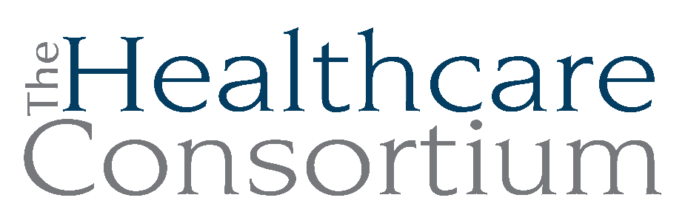
Notes from the Executive Committee meeting of March 4, 2026

Note: This meeting occurred virtually on the Zoom web platform

Attendance
Committee Members: Art Proper, Becky Polmateer, Maria Ostrander, Karen Amanna
Staff Members: Claire Parde, Lisa Thomas

General Updates

- Fiscal
Claire reported that the NYS contracting process has been extremely slow. The contracts for the Navigator Program, which started on August 1st, and the RHNDP, which started on October 1st, aren’t fully executed yet, making it impossible for us to be reimbursed for expenses. As a result, our accounts receivable is quite large, and we are delaying moving our excess cash from our online savings account with Live Oak Bank into Certificates of Deposit until the State starts to pay our vouchers.

Claire created a voucher checklist to assist Greg, the Director of Finance, with timely submissions.

W-2s, 1099s and total compensation statements went out to staff. The total compensation statements are for regular employees and list the value of each benefit, including pay for time not worked (i.e. for personal and vacation leave, sick time and holidays) as well as health, dental, and other insurances. While we understand that staff focus on pay, we feel it’s important to present them with the value of their compensation once annually.

Employer contributions to 401(k)s were also made.

The business lines of insurance increased by 28%. Our experience with USI was not a good one, so are currently taking steps to change our broker to Amsure.

- Staffing
Claire reported that we are fully staffed in the Navigator Program at 3.6 FTE.

CARTS is moving to 325 Columbia Street. The County Facilities Department made modifications to the office to make this move possible.

We will be adding 0.5FTE to Greene County NY Connects as the budget can support this. We had hoped to add a 1.0FTE to NY Connects with 0.5FTE in Columbia Conty and 0.5FTE in Greene County, but NYSOFA declined to provide additional funding to Columbia County NY Connects to support this. As a result, we have offered our existing part-time Navigator the opportunity to take on the part-time role with Greene County NY Connects, which she was quite happy to do. This new configuration will commence on April 1st.

- Friends of the Consortium Event
Claire and Sydney are working on the Friends of the Consortium event, which is scheduled for Wednesday, April 1st at Hudson Hall. Julia Brandi from the Rip Van Winkle Foundation will be honored as the Friend of the Consortium for 2026. She has been a strong advocate for the CARTS Program and facilitates connections for us. She has also agreed to be our first Ambassador in our new Ambassador Program. Invitations for the Friend Event will be sent out today. Additionally, our Annual Impact Report is currently being finalized and will be linked to in our newsletter, which will be distributed next week.

The Friends Event will follow the Consortium’s regular Board meeting and Annual Meeting, both of which are scheduled for 2:30-3:30 p.m., in person, in the large conference room on the second floor of the Human Services Building. Election of new Board members and Officers will take place at the Annual meeting; Claire will provide Maria and Becky with a “governance script” prior to the meeting to help them with directing the nomination and elections process. We are still searching for member to serve as Vice President, given that Karen has vacated the role to serve as Treasurer.

- Audit Prep

Claire shared that the on-site portion of the external audit of the Consortium’s financial statements will be the week of March 30th. Greg is working on the items requested. Claire is in direct contact with the auditors and will be notified if issues arise.

- Office Equipment

Claire reported that our phone system and copiers/scanners/faxes are all at “End-of-Life.” We will also be moving off physical servers and onto “the cloud.” Although we will assign as much of these expenses to contracts as we are able, it is helpful to have a general fund to absorb expenses that cannot otherwise be allocated.

- 5310 Audit

We receive funding from the NYS Department of Transportation for our wheelchair-accessible van. Jim and Lisa recently completed mandatory training in preparation for an on-site audit. There are significant requirements, including developing a maintenance plan.

- Fiscal Policies

Claire, Greg and Lisa have been reviewing and revising the Fiscal Policies, which will be reviewed by the Budget and Finance Committee and full Board.

Next meeting
The next meeting of the Executive Committee will be on May 6, 2026 at 9:00 a.m. via Zoom.

