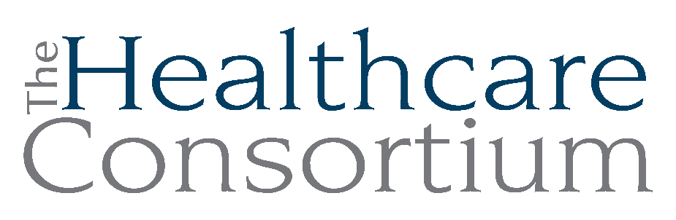
Notes from the Executive Committee meeting of May 6, 2026

Note: This meeting occurred virtually on the Zoom web platform

Attendance
Committee Members present: Becky Polmateer, Victoria McGahan, Art Proper
Committee Members Absent: Maria Ostrander, Karen Amanna (excused)
Staff Members: Claire Parde, Lisa Thomas

General Updates

- Friends of the Consortium Event
Claire reported on the presence of staff from 1199/SEIU at the event, including the disgraceful conduct of Colleen Hemmings, VP of 1199/SEIU, who disrupted the award ceremony, and the follow-up that was required later that night and the next day. She particularly highlighted the brilliant way in which Board President, Becky Polmateer, handled the situation, for which she was and remains exceedingly grateful.

Claire also noted that the event was not very well-attended by board members (7 out of 20 members attended), although it is technically a Board-sponsored event. She will bring this concern back to the Governance Committee for further discussion to determine whether it should be continued.

- Cash Flow
Claire reported that we have started receiving funds from our NYS contracts. We have been paid for August through November for the Navigator Program. This has modestly improved our cash position, but we will be more satisfied when the State completely catches up on payments, likely after the FY27 NYS budget is approved.

- Navigator Program
Claire reported that we are currently in the 7th year of what was to be a 5-year contract. The current contract is due to end on January 31, 2027.

We have received the Request for Applications for Navigator for the next 5 years beginning February 1, 2027. We have taken a Team approach to completing the application. There are some differences to previous applications. We now must submit a separate application for each county we propose to serve, which has its challenges, especially when preparing budgets. Nevertheless, we are on track to submit by the deadline of May 14th, if not earlier. Award announcements will be made on or after October 10th.

NYS has indicated that they want two vendors for every county, but there really isn’t enough demand to warrant this. In the past, the Community Services Society (CSS) out of NYC subcontracted with agencies across the State, but this model wasn’t that successful in Columbia and Greene Counties; those subcontractors had no discernible presence here.

When asked if there were other organization that might submit a competitive application, Claire indicated that she wasn’t aware of any locally, but had received a communication from the Healthy Capital District (HCD) regarding their interest in applying for Columbia and Greene Counties in addition to the three counties in the Capital District that they currently serve. Claire advised Amanda to contact CSS to determine if they would again be applying to serve the Twin Counties, as they had in the past, and expects Amanda to report back.

We do expect the demand on the Navigator Program to increase next year, when Medicaid enrollees will need to renew their coverage every 6 months. Moreover, both enrollees and applicants will need to demonstrate that they have fulfilled the “community engagement requirements,” which can be met with work, school, volunteer service, or some combination thereof. According to language incorporated in the Request for Applications, new Medicaid applicants will need to complete 80 hours of community engagement in the month prior to applying, and existing enrollees will need to complete 80 hours in any one month out of the six prior to renewing their coverage. Our Navigators are already educating clients on this new requirement. We will also create and maintain a Volunteer Resource Directory so Navigators can provide clients with possible volunteer opportunities. Claire will be reaching out to Network Members and other organizations to see which agencies are currently able to provide volunteer opportunities or could do so in the future in order to support their readiness.

Next meeting
The next meeting of the Executive Committee will be on July 1, 2026 at 9:00 a.m. via Zoom.

